Hypothesis Testing:
It id used to evalute 2 mutual exclusive statements.
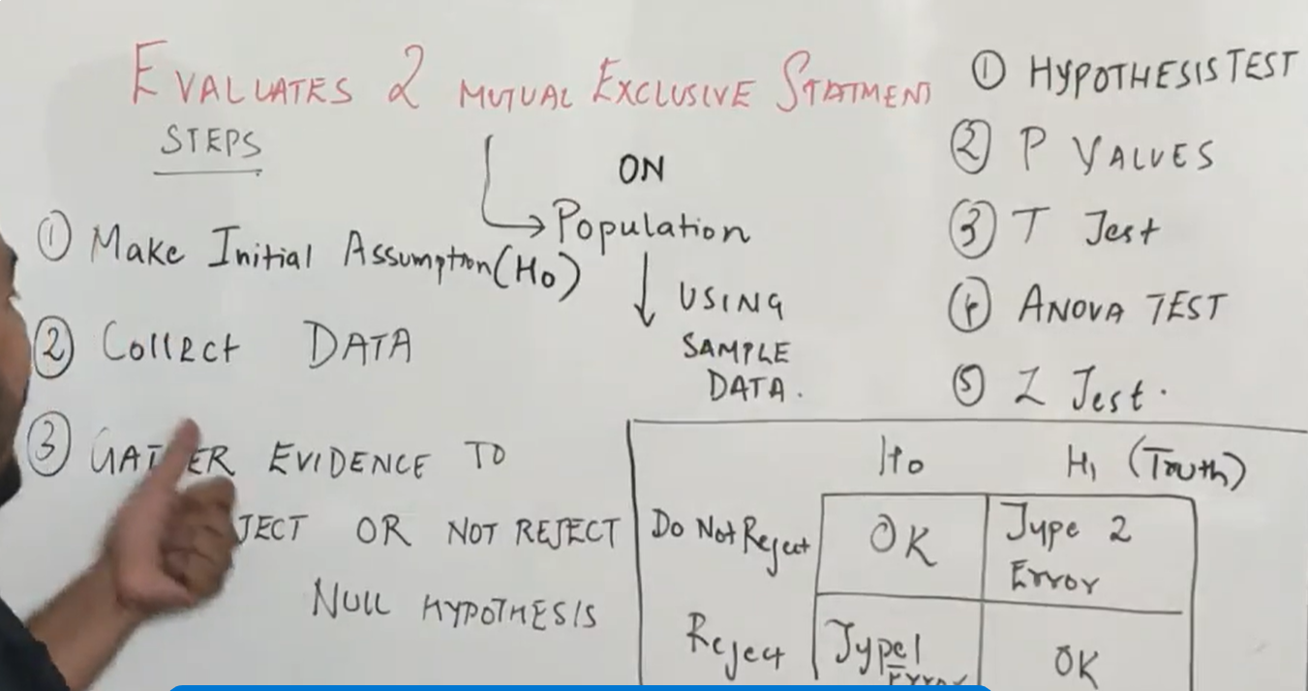
For example :
We take the evidences to find the man is innocent or criminal.
Here we set the intial to null hypothesis
And it also has h1 hyp[othesis which is the reverse of it .
Supouse if the null hypothesis is actually true , but I don’t have many evidence , then the null hypothesis will be rejected .
And it goes the alternate hypothesis.
Type1 error happens in null hypothesis.
Type2 error happens in h2 .

